[](https://rimj.org/2789-4711/?id=4.2.170)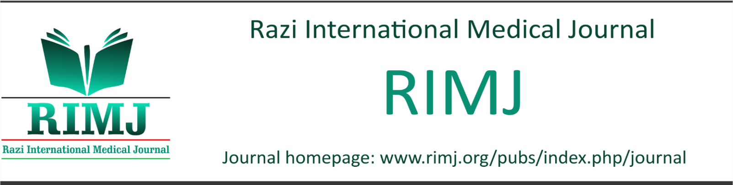

EDITORIAL | **Open Access | *Received:* 2024-10-16 | *Accepted:* 2024-11-05 | *Published:* 2024-11-30

**Afghanistan: Girls plight to access education**

**Ahmad Neyazi**1[1]✉

**1** Afghanistan Center for Epidemiological Studies, Herat, Afghanistan

The Taliban's systematic imposition of restrictive policies against women and girls has unleashed a profound humanitarian crisis in Afghanistan, with far-reaching implications for health, education, and societal stability. The denial of fundamental rights, coupled with oppressive governance, has created an environment of despair, particularly for Afghan women who bear the brunt of these draconian measures (1).

Central to this crisis is the Taliban's ban on female education beyond primary school, which has resulted in a cascade of detrimental outcomes. The prohibition not only denies girls their right to education but also undermines the future of Afghanistan's healthcare workforce. Women are now barred from pursuing medical training, exacerbating an already critical shortage of female healthcare professionals. This shortage is compounded by policies requiring women to be treated only by female doctors, creating insurmountable barriers to accessing even basic medical care (1).

The impact on maternal and newborn health has been particularly catastrophic. Restrictions on healthcare access, combined with the limited availability of female medical practitioners, have escalated maternal and neonatal mortality rates. Public health services, already fragile due to decades of instability and poverty, are collapsing under the weight of these regressive policies (2).[](https://creativecommons.org/licenses/by/4.0/)

The professional environment for female healthcare workers is equally disheartening. With wages reduced to a meager $70 per month and increasing job insecurity, many female professionals are abandoning the field (3). This exodus not only jeopardizes immediate healthcare needs but also threatens the long-term sustainability of medical services for Afghan women and children (2-3).

Moreover, the mental health toll on Afghan women—both those excluded from education and those struggling within the healthcare system—is immense. Marginalized and silenced, women face isolation and discrimination, leading to widespread psychological distress. This erosion of dignity and opportunity reflects a broader societal collapse under Taliban rule (2).

The path forward requires more than emergency aid; it demands systemic reform. Afghan women must be reintegrated into decision-making processes to ensure that national policies address their needs and aspirations. Only by empowering women can Afghanistan hope to rebuild its healthcare system and restore dignity to its citizens (4).

Cite this article as: Neyazi, A. Afghanistan: Girls plight to access education. *Razi International Medical Journal*, 4(2). DOI: [10.56101/rimj.v4i2.170](https://doi.org/10.56101/rimj.v4i2.170)

The exclusion of Afghan women from education, healthcare, and governance has set the nation on a path of deepening crisis. Without immediate and coordinated action, the suffering of Afghan women and girls will persist, and the country's public health infrastructure will face irreversible damage. The international community, in partnership with Afghanistan, must work to ensure that the rights and futures of Afghan women are no longer negotiable but safeguarded as a cornerstone of national recovery and stability (5).

The international community bears a moral responsibility to act decisively. Governments, the United Nations, and global organizations must prioritize negotiations to ensure the delivery of humanitarian aid without interference. Additionally, mechanisms to fund essential workers and food security programs should be implemented to alleviate immediate suffering. Concurrently, the Taliban must be urged to respect human rights and reverse their oppressive policies, beginning with the restoration of education and employment opportunities for women.

**Conflicts of interest**

None.

**Author contribution**

This article has been written by a single author.

**Sources of funding**

None.

**Ethical approval**

Not available.

**Consent**

Not available.

**References**

1. *Neyazi A, Padhi B, Sah R, Global Centre for Public Health Collaborators. Girls’ education and the future of healthcare in Afghanistan. bmj. 2023 Mar 13;380.*
2. *Mohammadi AQ, Neyazi A, Habibi D, Mehmood Q, Neyazi M, Griffiths MD. Female education ban by the Taliban: a descriptive survey study on suicidal ideation, mental health, and health-related quality of life among girls in Afghanistan. Journal of Public Health. 2024 Sep;46(3):e439-47.*
3. *حکومت طالبان: حقوق همه کارمندان زن ۵ هزار افغانی تعیین شده است [Internet]. BBC; 2024 [cited 2024 Nov 27]. Available from:* [*https://www.bbc.com/persian/articles/cv22d4q7vw9o*](https://www.bbc.com/persian/articles/cv22d4q7vw9o)
4. *Hamidi AB. Restriction Policy on Afghan Girls' Education and its Consequences. Edukasiana: Jurnal Inovasi Pendidikan. 2024 Apr 4;3(2):228-43.*
5. *خواجه میر اسلام سعید, محمد نعیم دولتی, احمد نیازی. ممنوعیت تحصیل دختران، عامل تهدید کننده ی صحت عامه. ژورنال علوم طبی افغانستان. 2023 Aug 9;1(1):1-2.‎*

1. ✉Corresponding Author: Ahmad Neyazi

   Email address: [neyazi.a@aces-af.org](mailto:neyazi.a@aces-af.org)